# AWR

## OS

* CPU: OK
* Memory: OK
* IO: OK

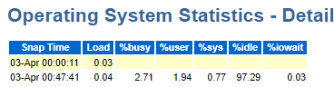

## DB

Sự cố chỉ xảy ra vào node 1

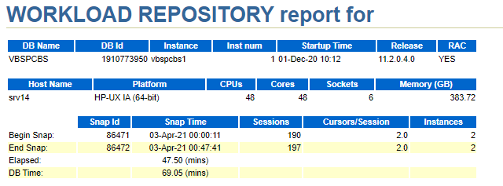

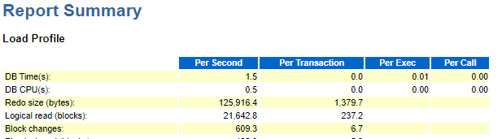

* DB thấp tải

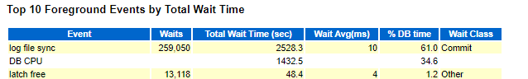

* Wait chính là log file sync

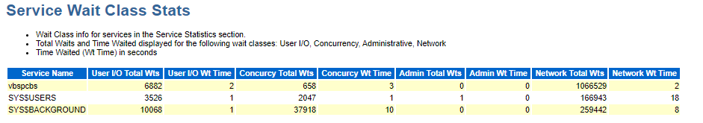

* Wait ở backgroud process

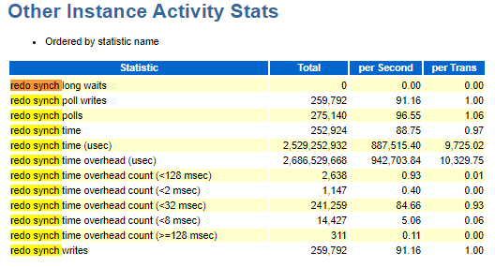

* **Adaptive Log File Sync Optimization (Doc ID 1541136.1)**
* Using Polling and take a lot of time
* Post/wait - traditional method available in previous Oracle releases  
  LGWR explicitly posts all processes waiting for the commit to complete.  
  The advantage of the post/wait method is that sessions should find out almost immediately when the redo has been flushed to disk.
* Polling  
  Foreground processes sleep and poll to see if the commit is complete.  
  The advantage of this new method is to free LGWR from having to inform many processes waiting on commit to complete thereby freeing high CPU usage by the LGWR.

# Root cause:

**Bug 13707904 - LGWR sometimes uses polling, sometimes post/wait (Doc ID 13707904.8)**

## Rediscovery Notes

Log file sync switches between post-wait and polling even for same workload.

## Workaround

Disable adaptive log file sync by setting

ALTER SYSTEM SET "_use_adaptive_log_file_sync"=FALSE;

## Solution

Upgrade database to higher version : 19c

# Other recommend

## Redo config

-----------------------------------------------------------------------

Redo size: 4G

Log all day : 100G -> 600G

-> switch 150 times/day -> 6 time/hourse -> OK

Group 4

Member/group : 2, but One diskgroup

-> Add more member to another diskgroup : ( RECO )

alter database add logfile thread 1 group 11 ('+DATAC1','+RECOC1') size 4G;

alter database add logfile thread 1 group 12 ('+DATAC1','+RECOC1') size 4G;

alter database add logfile thread 1 group 13 ('+DATAC1','+RECOC1') size 4G;

alter database add logfile thread 1 group 14 ('+DATAC1','+RECOC1') size 4G;

alter database add logfile thread 2 group 21 ('+DATAC1','+RECOC1') size 4G;

alter database add logfile thread 2 group 22 ('+DATAC1','+RECOC1') size 4G;

alter database add logfile thread 2 group 23 ('+DATAC1','+RECOC1') size 4G;

alter database add logfile thread 2 group 24 ('+DATAC1','+RECOC1') size 4G;

alter system switch logfile;

alter system switch logfile;

alter system switch logfile;

alter system switch logfile;

alter system checkpoint global;

alter database drop logfile group 33;

alter database drop logfile group 34;

alter database drop logfile group 35;

alter database drop logfile group 36;

alter database drop logfile group 41;

alter database drop logfile group 42;

alter database drop logfile group 41;

alter database drop logfile group 42;

## AWR snapshot

-> change snap to 30 min

## Not using user sys to query in database

## Check DBMS scheduler

# Reference

* **Adaptive Log File Sync Optimization (Doc ID 1541136.1)**
* **Bug 13707904 - LGWR sometimes uses polling, sometimes post/wait (Doc ID 13707904.8)**